-- Online SQL Editor to Run SQL Online.

-- Use the editor to create new tables, insert data and all other SQL operations.

-- create a table

CREATE TABLE students (

id INTEGER PRIMARY KEY,

name TEXT NOT NULL,

gender TEXT NOT NULL,

Qualification TEXT

);

-- insert some values

INSERT INTO students VALUES

(1, 'Ryan', 'M',"B.E"),

(2, 'Joanna', 'F',"BBA");

-- fetch some values

SELECT * FROM students;

CREATE TABLE Guvi_ZEN_Class

(

DAY INTEGER PRIMARY KEY,

TOPIC TEXT NOT NULL,

TASK TEXT ,

MENTOR TEXT DEFAULT "Sanjay"

);

INSERT INTO Guvi_ZEN_Class

(DAY, TOPIC, TASK)

VALUES

(1, "Introduction to Browser & web", "Introduction to Browser & web"),

(2, "Request & Response cycle", "Request & Response cycle"),

(3, "JS array & objects", "Looping Of Arrays & Objects"),

(4, "What is XMLHTTP Request? & scope", "XMLHTTP Request"),

(5, "Functions", "IIFE & Annoymous Function"),

(6, "Functions recap", "Functions"),

(7, "ES5 vs ES6", "NIL"),

(8, "OOP", "OOP PROBLEMS"),

(9, "MRF Array Method", "MRF Method"),

(10, "Complete Recap", "NIL"),

(11, "HTML", "HTML & CSS Mini Task"),

(12, "HTML recap CSS", "NIL"),

(13, "CSS", "NIL"),

(14, "CSS", "NIL"),

(15, "Responsive web design", "NIL"),

(16, "Bootstrap design demo", "Responsive Design"),

(17, "DOM", "NIL"),

(18, "Document vs Window", "NIL"),

(19, "Recap of Topics", "CALCULATOR HTMLForms PAGINATION"),

(20, "Recap of Topics", "NIL"),

(21, "Callback", "Callback Hell"),

(22, "Promise", "NIL"),

(23, "Fetch Api", "NIL"),

(24, "Promise_fetch - request info & request init", "NIL"),

(25, "Recap of Topics", "3 API TASKS"),

(26, "REACT", "Pricing Table"),

(27, "React hooks & states", "Shop-Homepage"),

(28, "React components", "Dashboard"),

(29, "React router", "CRUD_Userlist"),

(30, "recap with previous day topics", "NIL"),

(31, "Context API", "API task completion using context"),

(32, "recap with previous day topics", "NIL"),

(33, "AXIOS", "CRUD using Axios"),

(34, "formik in react", "CRUD for product with validation"),

(35, "practice with formik & recap", "NIL"),

(36, "Database - MySQL", "MYSQL queries"),

(37, "Database - MySQL", "Design DB model for Guvi Zen class"),

(38, "Database - MongoDB", "MongoDB queries"),

(39, "MongoDB", "database-design-zen-class"),

(40, "Nodejs", "Nodejs file system"),

(41, "Nodejs & Expressjs", "Hall Booking Application"),

(42, "Node & mongo DB connectivity", "Mentor and Student Assigning with Database"),

(43, "Nodejs deployment", "Mentor and Student Assigning with Database"),

(44, "Authentication", "Password Reset Flow"),

(45, "JWT", "URL Shortener Application");

select * from Guvi_ZEN_Class

INSERT INTO Students

VALUES (3,"Bharath S","M","BE"),

(4,"Praveen P","M","CSS"),

(5,"Manoj K","M","BAC"),

(6,"Nithish","M","ECE"),

(7,"SRI HARI K","M","EEE"),

(8,"Tharun","M","CSE"),

(9,"Kukila Singaram","M","BBA")

(10,"velmurugan r","M","Diploma"),

(11,"Balaji N","M","12th")

(12,"Dinesh","M","ME"),

(13,"Meenatchi","F","ECE");

--Alter Table

ALTER TABLE Students

ADD BATCH TEXT default "B51 WD2 Tamil";

--insert

INSERT INTO Students

VALUES(14,"PANDIARAJ M","M","CCS","B51 WD2 Tamil"),

(15,"Kesavan R","M","CSE","B51 WD2 Tamil"),

(16,"Rubin Raj","M","CA","B51 WD2 Tamil"),

(17,"SUNDARRAJAN S","M","ME","B51 WD2 Tamil"),

(18,"Abdulla J","M","BBA","B51 WD2 Tamil"),

(19,"SONIYA ATCHAYAKUMAR","F","EEE","B51 WD2 Tamil"),

(20,"Stalin Samuel Raja S R","M","BCA","B51 WD2 Tamil"),

(21,"Shreedhana Kathiravan","F","CA","B51 WD2 Tamil"),

(22,"Sriram R","M","ME","B51 WD2 Tamil"),

(23,"Kaviyarasan Kuppan","M","CS","B51 WD2 Tamil"),

(24,"SABAREESWARAN M","M","Diploma","B51 WD2 Tamil"),

(25,"Sriram Gokul","M","12th","B51 WD2 Tamil"),

(26,"Keerthana K","F","BCA","B51 WD2 Tamil");

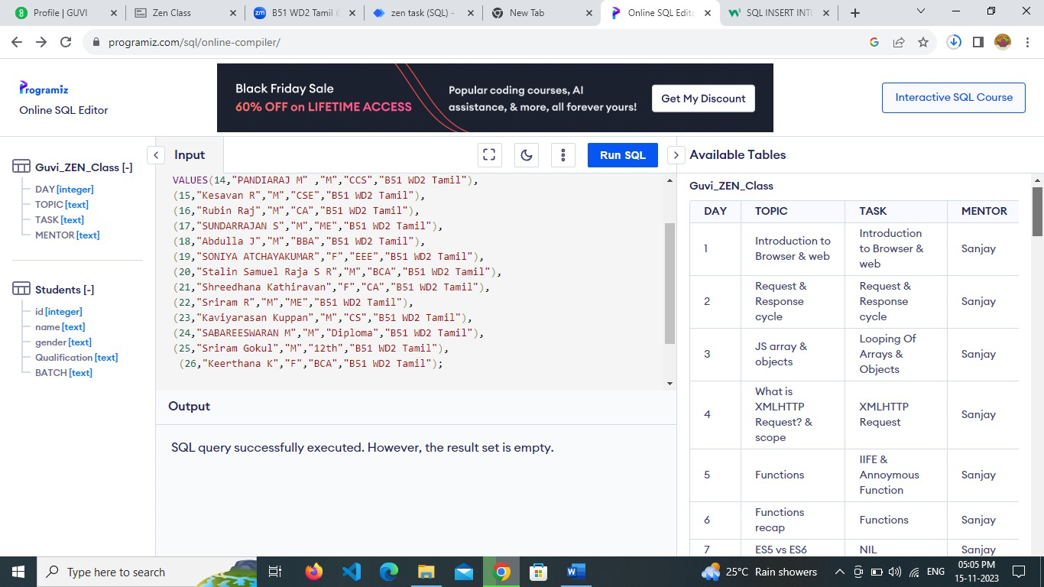

--join

SELECT * FROM Guvi_ZEN_Class INNER JOIN Students;

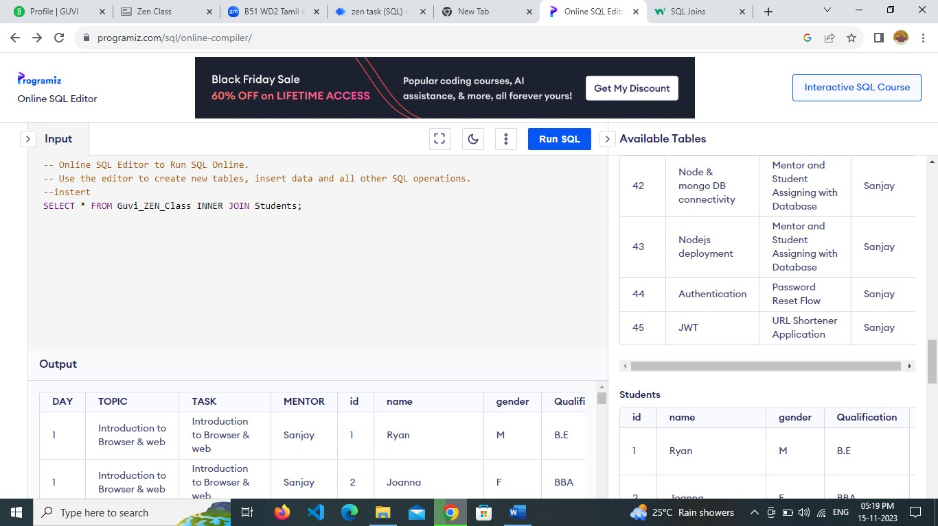

--update

UPDATE Guvi_ZEN_Class

SET Mentor="Thirupathi"

WHERE Day=2;

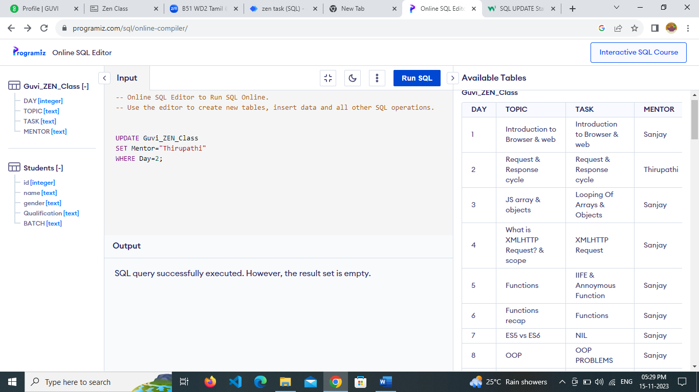

---Delete

Delete from Guvi_ZEN_Class where Task="NIL";

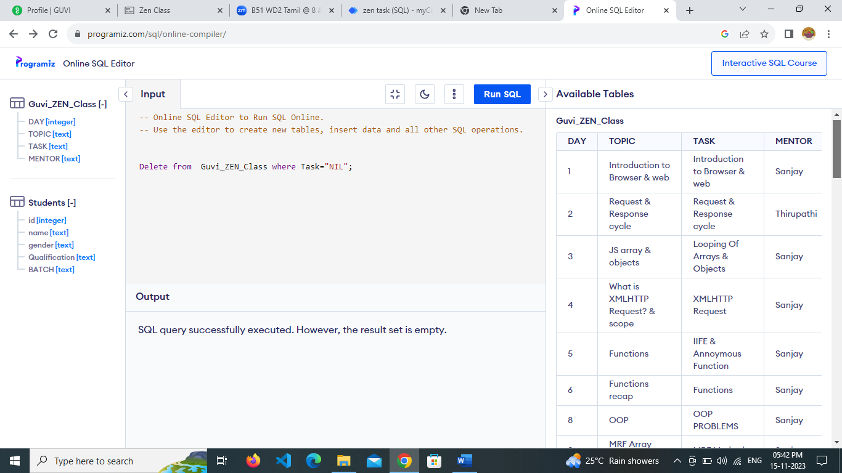

--Drop

DROP Table Guvi_ZEN_Class;

DROP Table Students;